OOP LAB 1(20225951)  
  
2.2.1. HelloWorld

2.2.2. FirstDialog

2.2.3. HelloNameDialog

2.2.4.ShowTwoNumber

2.2.5 Caculator

2.2.6 Solve  
6.1 ChoosingOption  
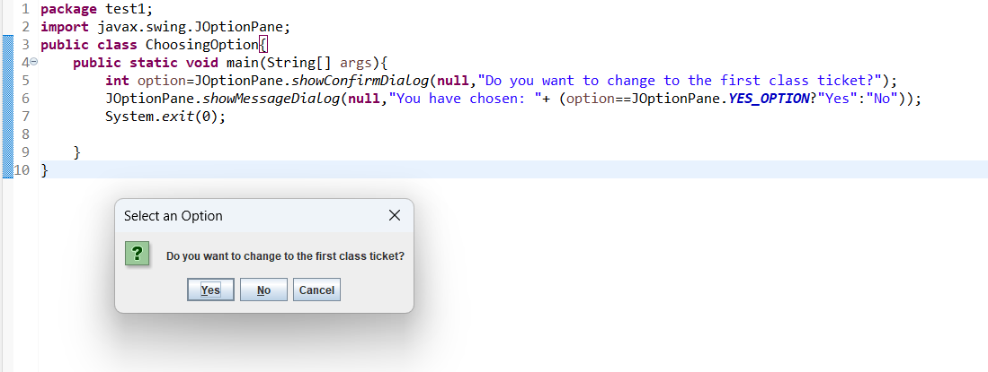

6.2 InputFromkeyboard

6.3 Trigle

6.4 ArraySortSumAvg  
6.5 MatrixxAdd  
